- Bluebook Page84 May 2019 variant three examination:
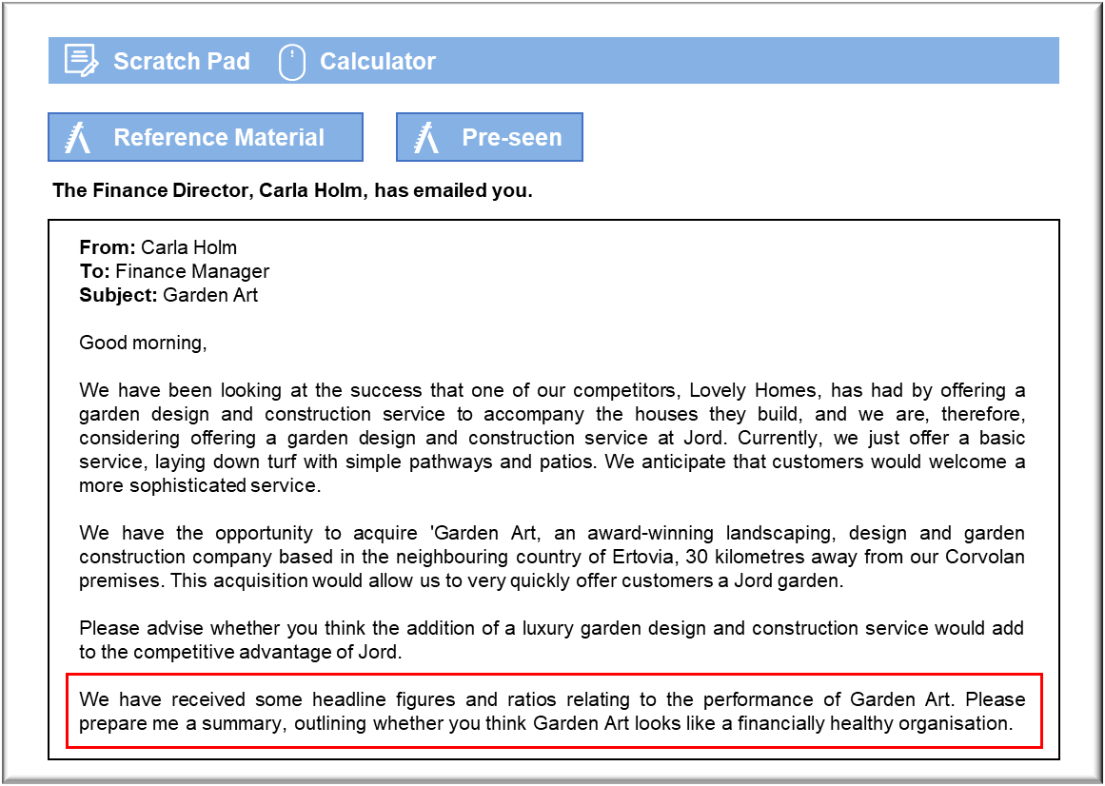

MANAGEMENT CASE STUDY MAY 2019 EXAM ANSWERS

Variant3 Task1
These answers have been provided by CIMA for information purposes only. The answers created are indicative of a response that could be given by a good candidate. They are not to be considered exhaustive, and other appropriate relevant responses would receive credit.

CIMA will not accept challenges to these answers on the basis of academic judgement.

Whether a luxury garden design and construction service adds to
competitive advantage
Jord is a differentiator, operating at the premium end of the prefabricated housing
market and charging a high price. This strategy is clearly working well, as Jord is
highly profitable and has a long customer waiting list. Competitive advantage currently
arises from a very high-quality offering with exacting standards, excellent levels of
customer service and a unique product offering that is sustainable and ethically sound.
Jord will have to undertake some discreet market research in order to establish
whether a graded design service would enhance competitive advantage. If customers
wish to be presented with a completed house, including a finished garden, then Jord
may be able to further differentiate itself by adding this service. Those customers
would prefer the greater simplicity of having the house and garden managed by a
single entity. It may be, though, that many house buyers will be keen to find and brief a
garden consultant who understands and shares their vision and so there may be little
interest in any consultancy that Jord acquires.
There may be concerns that a garden consultant will not have the experience of the
different climates and soil types that would be encountered because of the fact that
Jord builds homes in different countries. It would certainly harm Jord’s reputation if a
customer’s garden did not thrive because of the use of plants that were unsuited to
local conditions.
There are no particular synergies between the house construction and the creation of
the garden. It may be difficult for the customer to envisage what the garden design
would look like until after the house had been built. It would also be inconvenient for
the garden work to be undertaken during the house construction, because of the need
for the housebuilders to access the site with cranes and other equipment. In some
respects, Jord would be forced to operate housebuilding and garden design as two very
separate businesses, even if they were providing both services to the same customers.
There are some indications in the figures that suggest that, although the product
offering appears to be conceptually an excellent fit, Garden Art may have the described
potential to distract management time.
These answers have been provided by CIMA for information purposes only. The answers
created are indicative of a response that could be given by a good candidate. They are
not to be considered exhaustive, and other appropriate relevant responses would
receive credit.
CIMA will not accept challenges to these answers on the basis of academic judgement.

Financial health of Garden Art
It should be borne in mind that we have little direct interest in Garden Art’s financial
health as an independent entity because we ought to consider it as a potential
subsidiary of the Jord Group. For example, Garden Art’s revenue has fallen from 2017
to 2018. Following modest growth from 2016 to 2017 of 2%, sales fell by 17% from 2017
to 2018, to a level over E$1 million lower than that achieved in 2016. This is a
potentially worrying sign because it could imply reputational problems associated with
poor quality work, leading to declining sales. If that concern proves unfounded then it
should be borne in mind that Jord’s interest is in acquiring a consultancy that can
service housebuilding clients. Declining revenues could imply the availability of
resources, such as skilled labour and consultants, to start immediately on Jord’s
projects.
Operating profit margin is also disappointing, showing an organisation that is
struggling to cover costs, with one year in the period making a loss. It may be that the
cost base reflects high quality work and that could indicate that Jord will have to
ensure that it can enhance Garden Art’s revenues through obtaining commissions from
housebuilding clients. It is clear that Garden Art’s profits are sensitive to revenues.
Garden Art’s average salary seems very high, suggesting that it has skilled staff for
whom there is a considerable market demand. That reinforces the need to generate
revenues.
There is a similar argument with regard to wasted materials. It tends to imply a
tendency towards achieving high quality, even if there is a financial cost. That will have
to be considered before making an investment because curtailing waste could lead to
impairment of the quality of work.
Garden Art’s gearing is relatively high and rising. That is coupled with volatile cash
flows, which is a dangerous combination. The fact that Garden Art will be part of the
Jord Group means that it will receive greater support and may not be in any great
danger. It will also motivate the present owners to consider whether they wish to bear
the risks associated with continuing to operate independently. They may be motivated
to accept a relatively low purchase price if Jord makes the offer to buy them out.

